BVP 4th Grade Visionary
October 16, 2015
Vocabulary Review
Editor: Nikolas Estrada

1: My mom was concerned with the aesthetics of the hair salon; she wanted everything nice and clean.

2: At the hockey game, the goalie blatantly stood out with the big hockey net behind him.

3: When Evan received an invitation to his best friend’s birthday, he showed tons of alacrity.

School News
Editor: Norah Perez
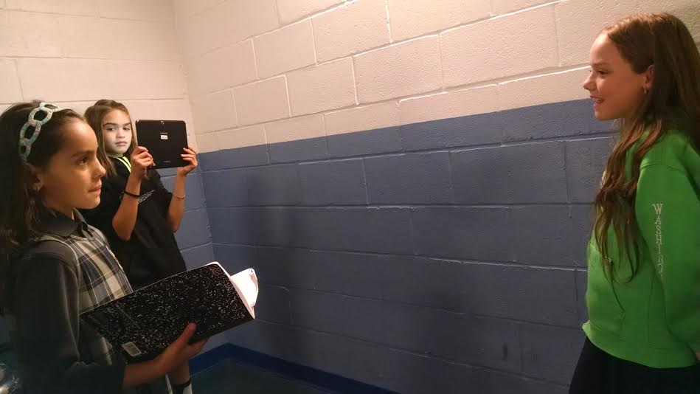
Hi fourth grade! This is a paragraph about what is happening in our school. One thing is for our fourth grade ladies, the lunch bunch is on Friday October 16th. Another thing is make sure your parents label your clothing so that it is easy to find who it belongs to. Also on October 12th-18th is the Central Falls Restaurant week. October 22nd is Read for the Record day so make sure on this day you dress like your favorite pet! We will be reading “Not Norman” by Kelly Bennett. Next, on October 28th we have the Fall Festival! October 30th is picture day! This is also the same day as our fieldtrip to Battleship Cove. There will be more information on that to come. Just a reminder that the 4th grade website is http://cmcorser.wix.com/4thgrade.

Art Feature: Self Portrait
Editor: Jacquelyn Proulx
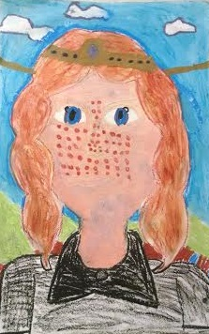

Interview with Ms. Lessard
Editor: Annyliz Abreu

- Where did you go to college? Stonehill College
- Where are you from? Lewiston, Maine
- What was the happiest moment and scariest moment in your life? Happiest: graduating college Scariest: skydiving
- What are your hobbies? Coaching cheerleading, running, spending time with my family & quilting
Editor-in-Chief: Eduardo Villaseñor
Creative Writing Prompt: Imagine you opened your own restaurant, tell us about it!
Editor: Elizabeth Barakat
Dear diary, today I opened a restaurant. I call it Lizzie’s Luscious Looking goods. It looks like a normal brick building except on the roof it has all different kinds of food. The people who work there are my parents, my sister, my cousins, and my grandparents. I of course work as the manager/server/chef so I have a lot of jobs. Only the fanciest people come. Here is a sample of my menu; Todays specials are snail soup with an egg and sausage side. For dessert I will be making a fruit tart. Sincerely, Elizabeth Barakat

Math Tip
Editor: Isabella Valderrama
Factor rainbows are a way to figure out which factor pairs go into a larger number. Since I’m doing the math tip, I drew a little picture of factor rainbows to help you out! Here’s a reminder: for a prime number there will only be one pair of factors- 1 and the number itself.
