BVP 4th Grade Visionary
November 4th, 2015
Vocabulary Review
Editor: Jack Kanakry

1: A cliché I think is overused is “you smelt you dealt it.”

2: When the bungee cord holding a kid hanging broke everyone closed their eyes as the kid fell and said, “This is quite the debacle.”

3: My foot was debilitated because I dropped a brick on it and had to get a cast.

School News
Editor: Cassidy Youssef

Hi fourth grade. Make sure next month you’re showing PRIDE values so you can reach 100 points and go to the premium glow stick party! Also there will be an FLC event on Wednesday November 18th from 5:30-7:30 p.m. There will be crafts, games, and fun. There will be great snacks, so make sure you participate! Also if you can, please bring a dollar donation or a canned good!

Art Feature
Editor: Julia Pepin
Creator: Izzy Valderrama
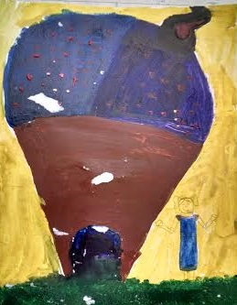

Math Tip
Editor: Zyen Rosado

Divide
Multiply
Subtract
Bring Down
Repeat
Since I’m doing the math tip, I am giving you a little example of long division.

Editor-in-Chief: Eduardo Villaseñor
Creative Writing Prompt: Imagine you opened your own restaurant, tell us about it!
Editor: Sawyer

Dear Diary,
I just opened a restaurant and it is named Sawyer’s Kitchen. It has a lot of art in gold and diamonds. The people that work there are in my family! I serve anything!
Interview with Mr. Murray
Editor: Ariv Chadha

What college did you go to? I went to CCRI for 2 years, and then I finished my college years at URI. I graduated with a degree in Physical Education, Health, and adaptive Physical Education.
How is your family? My family is great! Every day I drive home from BVP and I can’t wait to see my beautiful wife and two boys Lucas and Landon.
What is your favorite food? I absolutely LOVE my wife’s famous steak and cheese quesadillas.
What is your favorite restaurant? My favorite restaurant is South of the Border.


